Prayer Spaces for Easter 2021
We begun the week with Worship Group preparing a retelling of Palm Sunday which we filmed and shared with all classes in both schools. Classes then looked at Joy connected to Palm Sunday and what makes them joyful. Each class looked at another prayer space for Easter connected to their RE learning e.g. Last Supper and the theme of friendship for Yr 5/6 who have been learning about the Eucharist. Yr 3/4 looked at what they could do to make a better world linked to their learning about Hinduism. All of the children made a prayer bookmark, cross or Easter card that we sent to Bentley and Copdock churches to be distributed within the community at Easter.
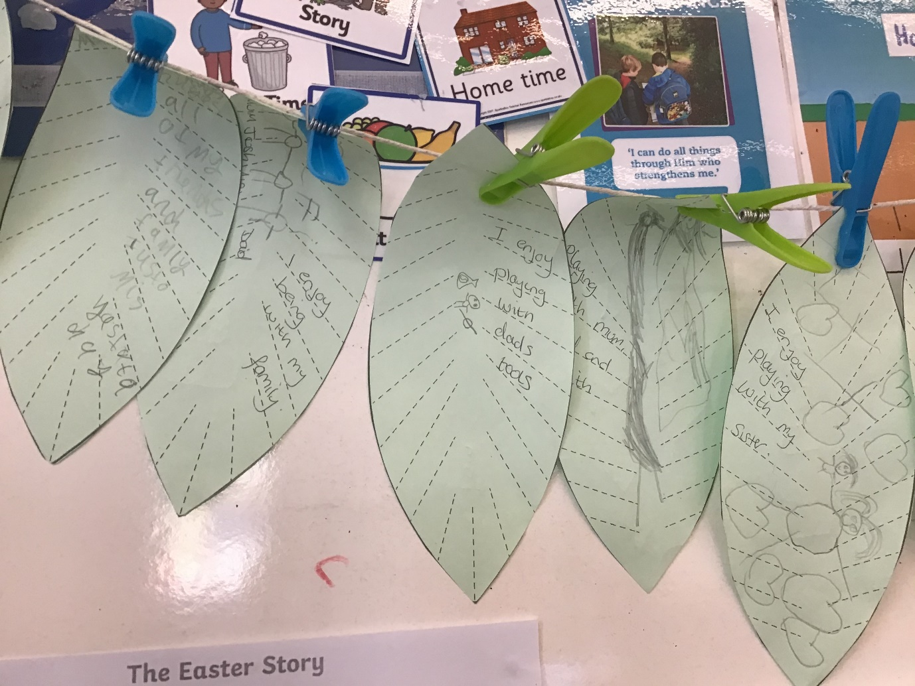
Being joyful – KS1
“They were super thrilled to see Jesus” (In the Palm Sunday story)
“Jesus died on the cross” Ace
“I am super thrilled to see Mum at home time.” Mario

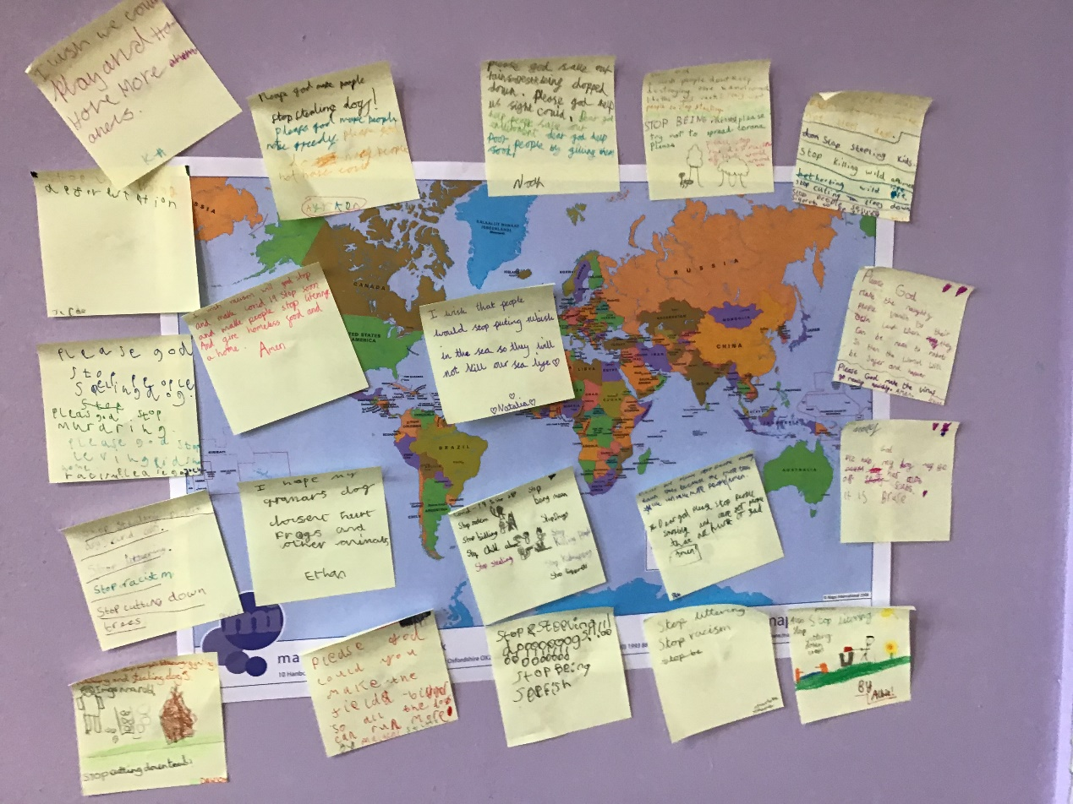
Year 3/4 – making our world a better place
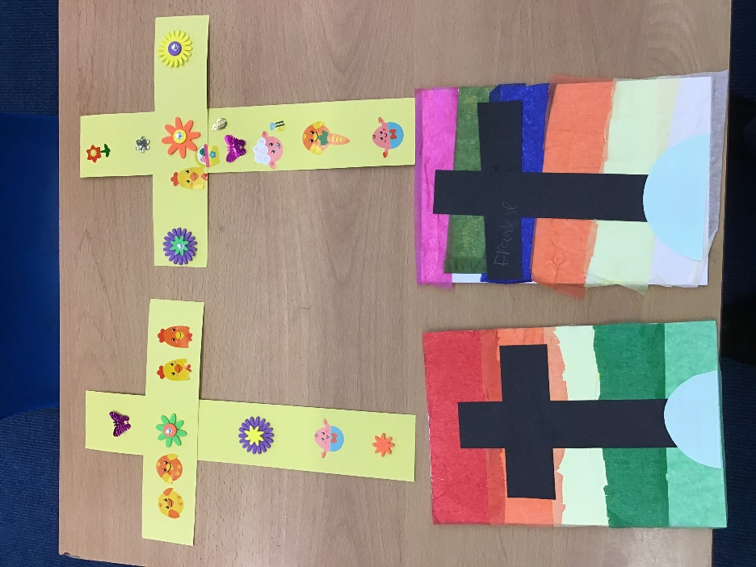
Cards and crosses for the Community – KS1
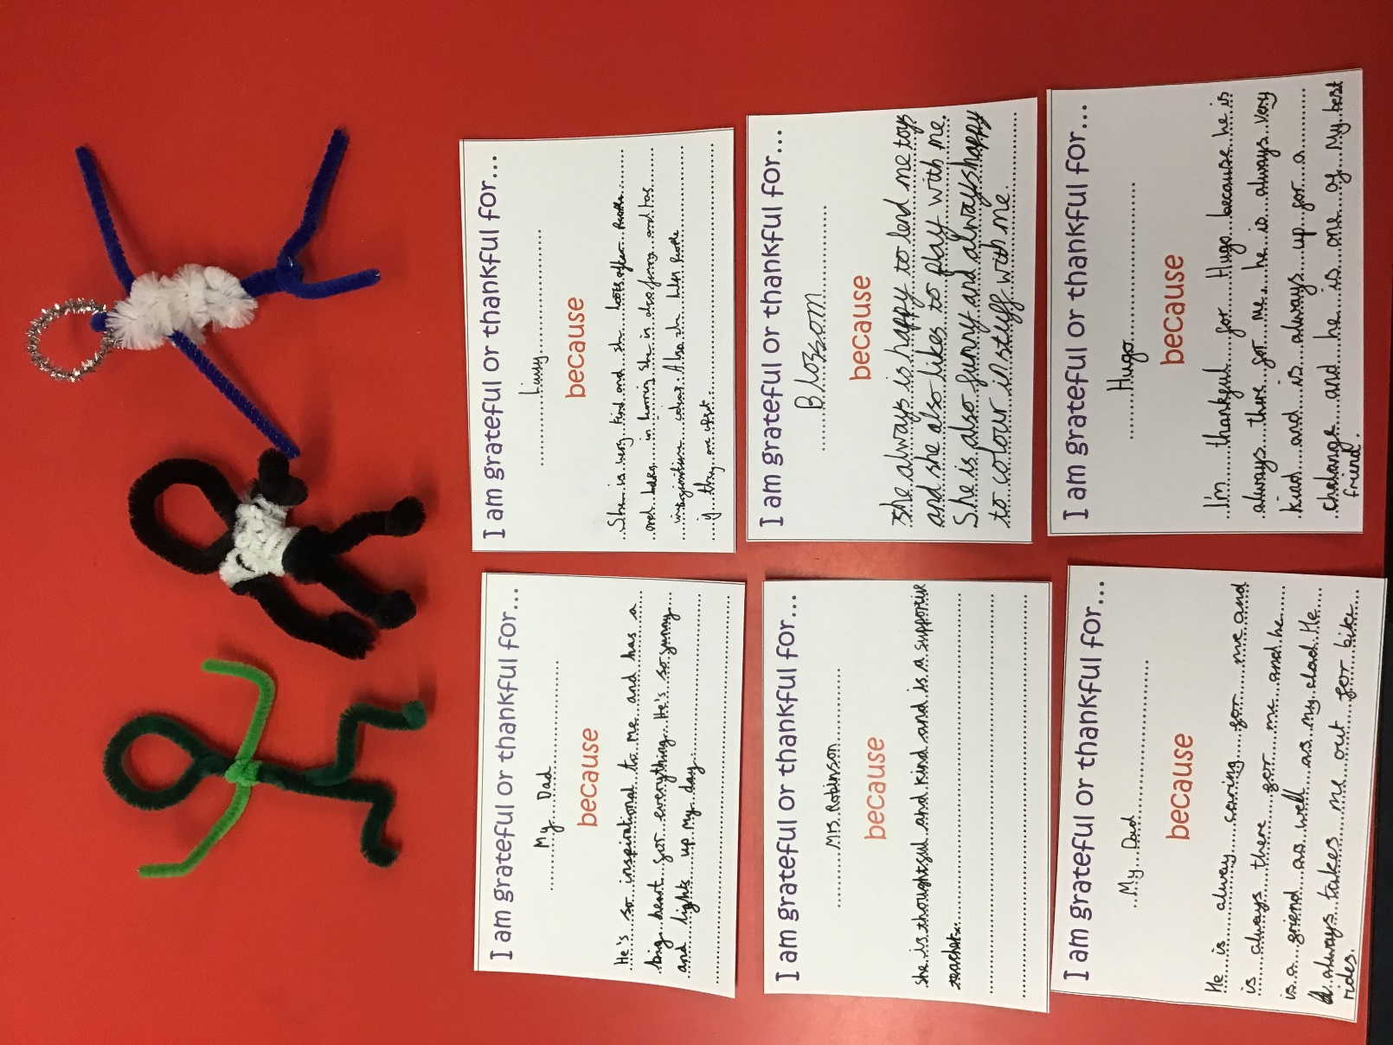
Friendship – Year 5/6
“My Dad cares for me, like Jesus cares for us.” Dylan
“Jesus gave bread and wine to his special friends and they were thankful.” Jacob
“My Dad is inspirational because he looks after everyone. Everyone is excited to see my Dad, like everyone was excited to see Jesus in the story of Palm Sunday.” Kate
This was then followed up by work in KS1 looking at why Christians pray and worship God at Easter and in Reception looking at why the symbol of the cross is important to Christians.
In Collective Worship on Wednesday, we looked at Holy Week through the art work of Ethiopian artist Nebiyu Assefa as we reflected on each part of the story.
In Collective Worship on Thursday we considered if we should give real eggs or chocolate eggs at Easter as a philosophy debate.
Finally on Friday, we had our Easter bonnet parade virtually and had a Creation Stations prayer space outside in the grounds at Bentley. This connected the Easter story to the damage being made to our natural world through pollution and deforestation and the children made pledges to make a difference to our natural world.
