Dear Parent/guardian,
Introduction to OneLife Suffolk

We are OneLife Suffolk, and we are delighted to have been invited by your school to come and work with the children in Years 5 & 6.

How we help local families

Suffolk County Council has commissioned us to provide a range of healthy lifestyle programmes for adults, children, and families. Our programmes include help to get active, support to quit smoking and weight management programmes for adults.

We also run a Families and Young People's service, which is why we are writing to you today. Our service is committed to helping families create positive habits and lifestyle changes that the whole family can keep and enjoy!

We also work with schools to educate children around essential health and well-being topics that help lay the foundations of a healthy lifestyle.

Starting on May 24, 2023, then June 14 – July 05, 2023, every Wednesday afternoon, we will be delivering sessions on; The Human Body, The Eat Well Guide, Portion Sizes and Snacks, Physical Activity, Sleep and Breakfast and Food Labels and Sugar in Drinks.

Within our school sessions, we will be encouraging the children to share with you, what they have learnt and any new goals they have made; we hope you will be pleased with what they share!

OneLife Kids Clubs

If your child enjoys their sessions and you think it has benefitted them, you might be interested in our free OneLife Kids Clubs. We build upon the sessions we have delivered at your school and encourage the whole family to participate in the healthy lifestyle change!

If you would like to know more about our OneLife Kids Clubs and what we offer, please head to: onelifesuffolk.co.uk or scan the QR code below.

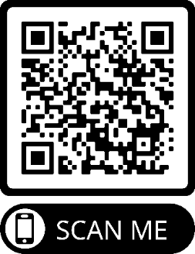
If you would like to talk to our programme coordinator directly, please don't hesitate to contact: anthea.williams@onelifesuffolk.co.uk or our practitioner halima.satti@onelifesuffolk.co.uk
Yours Sincerely
OneLife Suffolk Families and Young People Team

