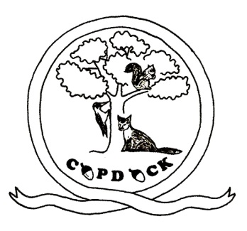
Copdock Primary School
School Hill, Copdock,

Ipswich, Suffolk
IP8 3HY
Telephone / Fax : 01473 730337
E-mail : admin@copdock.suffolk.sch.uk

Headteacher: J Austin
Web: www.copdock.suffolk.sch.uk

Oct 2023
School Uniform Order Form

Child’s Name…………………………..………………………………………… Class……………………………………………

Item | £ | 3-4  (24”) | 5-6  (26”) | 7-8  (28”) | 9-10  (30”) | 11-12  (32”) | 13  (34”) | Total cost
Crew neck sweatshirt, with crest | £10.00
Sweat cardigan, with crest | £11.00
Tee shirt, with crest | £5.50
Shower proof jacket, with crest | £20.30
Polar fleece, with crest | £15.00
 |  | One size only
Knitted winter hat, with “Copdock” | £5.00
Summer hat, with flap & “Copdock” | £5.50
Book Bag, with crest | £5.50
PE rucksack, with crest | £6.00
All items are Royal Blue, except tee shirts which are white. Total cost

Cash or Cheques payment included with order (made payable to “Copdock Primary School”)
School spider payment method.
Please tick payment method above
PLEASE SEND INTO THE OFFICE BY Wednesday 18th Oct 2023

Signed……………………………………………………………………………………………………………Date ……………………………..

