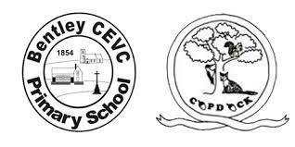**During this topic, we will be focussing on getting to know each other and our school area. We will look at the four seasons and how weather changes.**

All about me

|  |  |
| --- | --- |
| Family | A group of people consisting of children, parents, aunts, uncles, cousins and grandparents. |
| Home | The place where you live. |
| Respect | To take into consideration someone’s feelings and to care for all the resources |
| Listen | To look and pay attention to others. |
| Share | Taking turns to speak and listen when someone is talking.  To take turns using resources in the classroom. |
| Senses | How we explore the world |
| Seasons | one of the four parts of the year; spring, summer, fall, and winter. |
| Autumn | One of the 4 seasons |

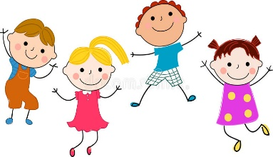

**How do we belong to a group?**

We will be getting to know our new friends by playing games, learning each other’s names. We will learn to write our own names.

We will be making up special promises to help us to get along, our classroom charter.

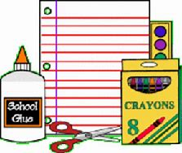

**What is our classroom area like?**

We will be exploring our indoor and outdoor classroom, playing with the resources and putting things away tidily.

**Curriculum Enrichment** – Go on a walk around our village and practise crossing the road safely.

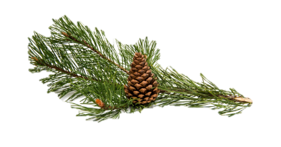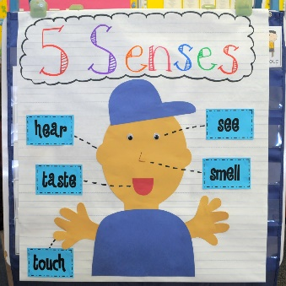

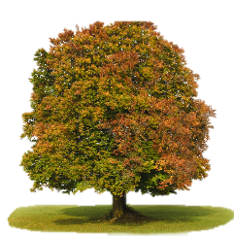

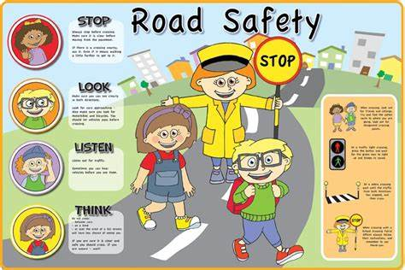

**What is around our school?**

We will be exploring the area around our school using our 5 senses, to help us get to know it. We will use our forest school area to find out more about what is growing and how it changes in Autumn.

Here are some of the word you might hear grown-ups use during your learning.

