Learning Project – Week 1 Florence Nightingale
Age Range: EYFS
Weekly Maths Tasks (Aim to do 1 per day) | Weekly Reading Tasks (Aim to do 1 per day)
- Go on a 2D shape hunt around your house, can you find examples of circles, squares, triangles and rectangles? Can you use them to create a shape picture on the floor? E.g. a man, a train, a teddy.  - Ask a grown up to collect a selection of objects that are circles, rectangles, triangles and squares and put them into a bag. Can you sort the objects into shape groups? E.g. a group of circles.  - Activity sheet – colour the sets of shapes the same colour e.g. colour all the triangles red. Colour all the circles blue etc  - Activity sheet – colour in the shapes. Then cut them out and make a repeating pattern e.g. circle triangle, circle triangle.  - Choose a shape card (provided). Count how many corners/vertices and sides it has e.g. a circle has 1 curved side and no corners. Repeat for each shape and then ask a grown up to play guess my shape. Place shapes into a bag . Grown up says -my shape has 4 corners and 4 sides. What’s my shape? | - Read together the booklet ‘All about Florence Nightingale and discuss.  - Reception age children: Children to read to parents daily. Visit Oxford Owl for free eBooks that link to your child’s book band -pink, red, yellow  www.oxfordowl.co.uk/ login - wsr12 bcps  - With your child, look in magazines, newspapers and books for the tricky words they are currently learning. They could use a highlighter to highlight in magazines and newspapers. Use the tricky word songs to help too.  www.youtube.com/watch?v=R087lYrRpgY  - Use Teach Your Monster to Read an interactive game to support phonics & reading activities. Free to use on laptops/home computers.  www.teachyourmonstertoread.com/
Weekly Phonics Tasks (Aim to do 1 per day) | Weekly Writing Tasks (Aim to do 1 per day)
- Sing Nursery Rhymes and songs together. Add in actions and change the words. Can children think of different rhyming words to add in? Repeat old favourites and learn new rhymes. You can find an A-Z of Nursery Rhymes.  - Daily phonics - Practice the sounds your child is working on and blend words. This can be oral blending (e.g. spoken out loud c-a-t) or written if appropriate. Use Interactive games on Phonics Play.  - Pour flour, rice or lentils into a shallow tray or plate. Show your child a letter, digraph, trigraph or tricky word and ask them to ‘write it’ in the food using their finger.  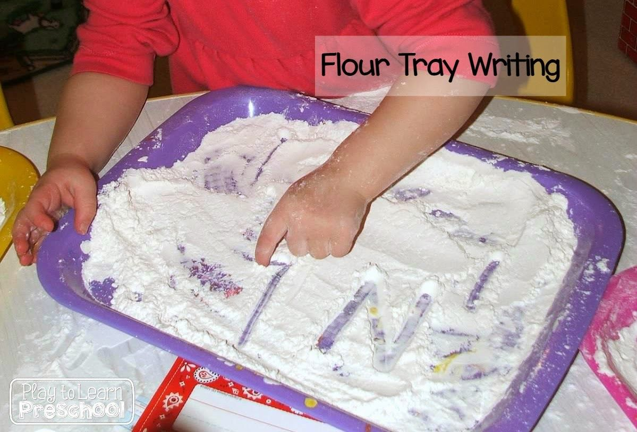  - Use Teach Your Monster to Read an interactive game to support phonics & reading activities.  www.teachyourmonstertoread.com/ | - Practice name writing. Can they write their first name? Middle name? Surname? How many can you write in 1 minute?  - Practice forming the letters of the alphabet using your handwriting mat and pen. The website below can support too.  wwdrwww.teachhandwriting.co.uk/handwriting-resources-children.htmlen.html  - Ask your child to write out the tricky words they are working on at the moment on pieces of paper and turn them into a pairs game or use the laminated ‘look, cover, write check’ boards.  - Use the ‘first aid box’ to write labels of items that might be needed by a nurse to care for the sick.  - Once you have explored all the resources on Florene Nightingale, can you draw/colour a picture of her and write 3 simple sentences about her. E.g. She had a lamp. She took care of the sick. She made the sick men better. Don’t forget your finger spaces, capitals & full stops!
Learning Project - to be done throughout the week
The project this week aims to provide opportunities for your child to learn about Florence Nightingale. They will explore who this special lady was and how she influenced nursing today. You may like to make links to the new Nightingale hospitals opening around the county.

- Read together the booklet ‘All about Florence Nightingale and discuss (provided)

- Watch Magic Grandad – Florence Nightingale YouTube Clip

- Make your own lamp like Florene Nightingale. She used a lamp to check on the sick when they were sleeping. This is why she is also called ‘the lady with the lamp’. Resources provided.

- Make you own nurses hat. Resources provided. Can you pretend to be like Florence and care for your sick teddies? Don’t forget to use your lamp to check on them when it gets dark!

- When Florence was young, she dreamed of being a nurse when she was older. What would you like to do when you are older? Draw a picture and write a sentence e.g. I want to be a police officer. Talk to your grown up about why you would like to do this e.g. because I want to keep people safe.

- Many other people help us in our community. Can you think of 4 more people who help to look after us or keep us safe in our community. Draw and label for 4 people and discuss with your grown up how they help us.
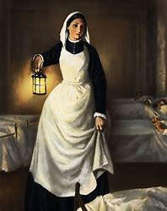

Additional learning resources parents may wish to engage with
Classroom Secrets Learning Packs - These packs are split into different year groups and include activities linked to reading, writing, maths and practical ideas you can do around the home.
Twinkl - to access these resources click on the link and sign up using your own email address and creating your own password. Use the offer code UKTWINKLHELPS.
Hamilton Trust -These packs are split into different year groups and include activities linked to reading, writing, maths and practical ideas you can do around the home.

