Answers 22/4/20
A Mother’s Diary
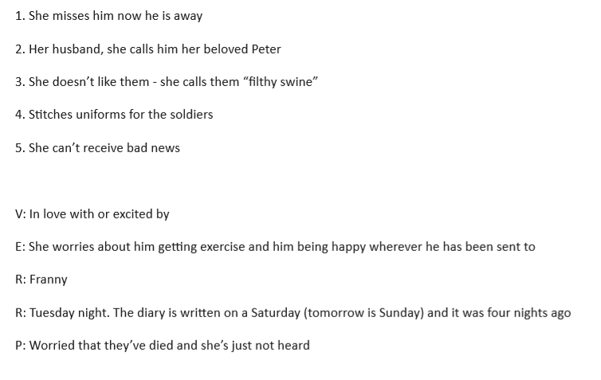
Year 5 Maths-Area of Rectangles
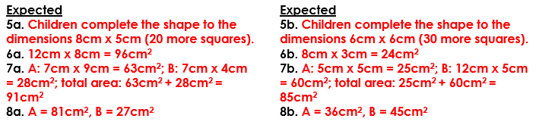
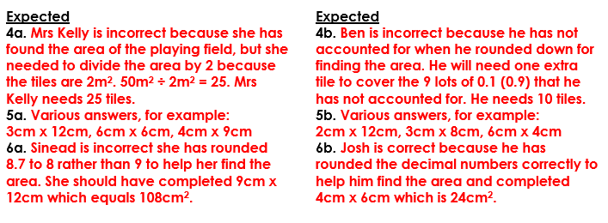

Year 6 Maths- Area of a Triangle 1
