Week 2: Learning Project – Food
Age Range: EYFS
Weekly Maths Tasks (Aim to do 1 per day) | Weekly Reading Tasks (Aim to do 1 per day)
- Explore weighing and measuring food on the kitchen scales. Ask, what happens as you place more on the scales?  - Look for numerals on packaging you find around the house. Can your child recognise the numerals and count out a matching amount?  - Ask a grown up to collect some food items e.g. carrot, cucumber. Sort the items into those that are long and those that are short.  - Find a teaspoon. Compare other items with the spoon and use the words shorter and longer. E.g. ‘The carrot is shorter than the spoon’. ‘The cucumber is longer than the spoon’.  - Read the story of the Hungry Caterpillar, who eats and eats and eats! A copy of this can be found on YouTube. Colour in the caterpillars (provided) to compare their length. | - Read The ‘Tiger Who Came to Tea’. A copy of this can be found on YouTube.  - Reception age children: Children to read to parents daily. Visit Oxford Owl for free eBooks that link to your child’s book band -pink, red, yellow  www.oxfordowl.co.uk/ login - wsr12 bcps  - With your child, look in magazines, newspapers and books for the tricky words they are currently learning. They could use a highlighter to highlight in magazines and newspapers. Use the tricky word songs to help too.  www.youtube.com/watch?v=R087lYrRpgY  - Look at recipe books and food magazines. Encourage your child to use their phonics knowledge to decode the ingredients list. Select a recipe and make this together. Encourage your child to read the labels on packaging to figure out which ingredient it is.
Weekly Phonics Tasks (Aim to do 1 per day) | Weekly Writing Tasks (Aim to do 1 per day)
- Sing Nursery Rhymes and songs together. Add in actions and change the words. Can children think of different rhyming words to add in? Repeat old favourites and learn new rhymes. You can find an A-Z of Nursery Rhymes.  - Daily phonics - Practice the sounds your child is working on and blend words. This can be oral blending (e.g. spoken out loud c-a-t) or written if appropriate. Use Interactive games on Phonics Play.  - Pour flour, rice or lentils into a shallow tray or plate. Show your child a letter, digraph, trigraph or tricky word and ask them to ‘write it’ in the food using their finger.  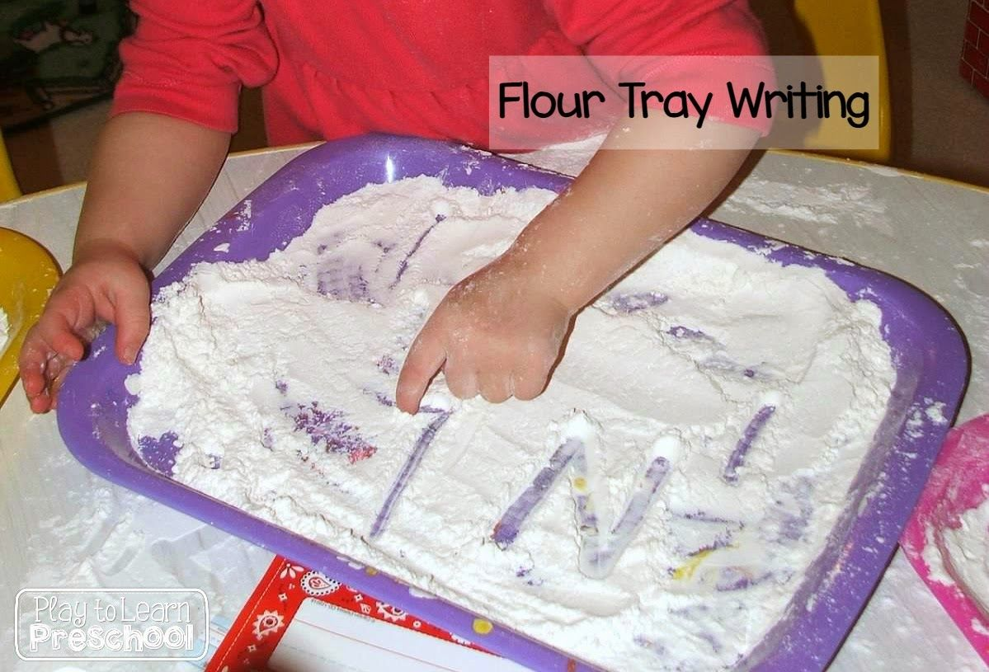  - Use Teach Your Monster to Read an interactive game to support phonics & reading activities.  www.teachyourmonstertoread.com/ | - Practice forming the letters of the alphabet using your handwriting mat and pen. The website below can support too.  wwdrwww.teachhandwriting.co.uk/handwriting-resources-children.htmlen.html  - Look at a range of different packages found around the kitchen. Discuss with your child what makes it stand out to a customer. Support them to design a package for a treat of their choice.  - Write a shopping list of items to buy the tiger just in case he visits Sophie again.  - Make a simple sandwich for the tiger in the story e.g. jam, ham, cheese. Discuss each simple step using the words like first, then, next, now, after, put, finally. Sequence pictures to show each step (provided) and ask your child to orally repeat each instructional step.  - Write simple instructions for making a sandwich. Provide a word bank of words First, Then, Now, Next, After. Don’t forget finger spaces, capitals and full stops.
Learning Project - to be done throughout the week
The project this week aims to provide opportunities for your child to learn more food. Learning may focus on where different foods originate from, what makes a healthy meal, opportunities to cook etc.
- Healthy/ Unhealthy-
  - Provide your child with a selection of items from your kitchen cupboards. Can they sort them into things that are healthy and unhealthy? Discuss why the food is good for you or bad for you. Look at the Eatwell plate to help figure out which foods they should eat a lot of or not very much of.

- Discuss how exercise is an important part of staying healthy. Watch and complete a 10 minute shake up.

- 5 a day-
  - Support your child to create a food diary to record how many pieces of fruit and vegetables they eat in a day. They could write these using their phonics knowledge or draw a picture of each item.

- Create a collage-
  - Ask your child to draw out a number of fruits or vegetables, large enough to fill a piece of A4 paper. Provide them with a selection of colourful packaging. Can they cut out and collage on to their picture as well.

- Play shops-
  - Using toy food or old packaging, set up a food shop for your child to act out being the shopkeeper and customer. You could introduce coins to support their developing knowledge of money. Give them a notepad to use as a shopping list to encourage in the moment writing.

- Potato/ Vegetable Printing-
  - Using a selection of vegetables available in your kitchen, support your child to print and explore the shapes and patterns created:
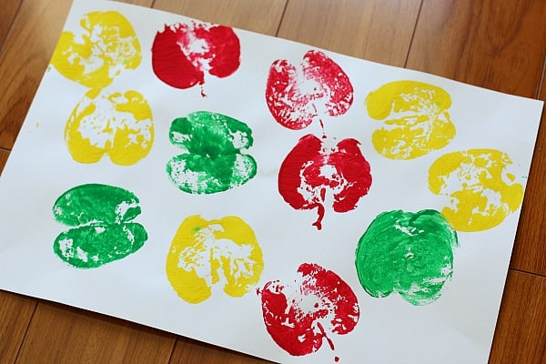
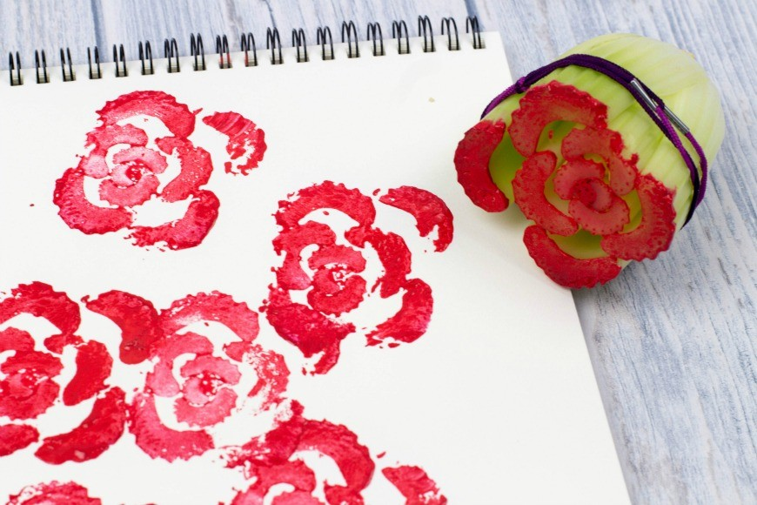
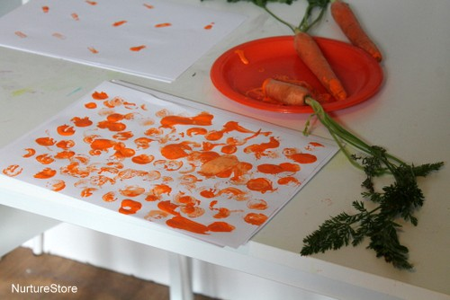

- Make cornflour gloop-
  - Mix cornflour with a small amount of water in a mixing bowl. It will make a slimy, stretchy mixture. Allow your child to explore the change of texture from wet to dry and the texture of the gloop.
Additional learning resources parents may wish to engage with
Classroom Secrets Learning Packs - These packs are split into different year groups and include activities linked to reading, writing, maths and practical ideas you can do around the home.
Twinkl - to access these resources click on the link and sign up using your own email address and creating your own password. Use the offer code UKTWINKLHELPS.
Hamilton Trust -These packs are split into different year groups and include activities linked to reading, writing, maths and practical ideas you can do around the home.
#TheLearningProjects

