Dear Parent/s,

We are delighted to say that Suffolk County Music Service have been granted permission by SCC to deliver online lessons to children and young people.

They have developed protocols and guidance for use by pupils, their families, and colleagues so that the lessons can run as smoothly as possible, and so that both students and staff are working in a safe and secure environment.

To sign up for online lessons, parents will need to visit their website to complete the parental consent form.

The full link is:https://www.suffolkmusichub.co.uk/take-part/online-learning/online-lesson-consent-form

Once SCMS receive this consent form the instrument tutor will contact you to arrange a mutually agreeable time for an online lesson.

I have also attached a couple of sections of information from the Music tutor’s guidance that you might find useful.

We look forward to working with you to quickly get your young musicians back engaged with their music learning as the lock-down continues.

Dear Parents & Musicians

We are delighted to launch our interactive online lessons. Suffolk County Music Service (SCMS) is the first team in Suffolk County Council’s Education and Learning department to meet and satisfy organisational protocols, and to be granted permission to deliver online lessons using interactive video conferencing technologies to children and young people.
Following the announced temporary closure of schools from Friday 20 March 2020, huge efforts have been made to move our programme of instrumental and vocal tuition (IVT) to an online and interactive offer. Working with SCC IT and HR Business Analyst colleagues we have explored various options to identify a suitable solution. Microsoft Teams will be the platform for our delivery.
This document aims to give some guidance as to how the Interactive Online lessons will work. It also aims to give some guidance to help get you and your child started in this world of online music lessons. It is not written by a tech guru, and will most likely not cover every eventuality! We do however hope that it will provide some help if it is needed.
The Table of Contents link to sections of the guidance.
Table of Contents
Enrolling students 1
• Registering IVT (Instrumental and Vocal Tuition) pupils for lessons 1
• Parent / Carer consent form 2
Interactive Online Teaching via Teams 2
• Setting Up Sessions (Lessons) 2
• Scheduling a Teams Meeting (lesson) 2
• Join a meeting without a Teams account (for Pupils) 4
• Safeguarding / Lesson Observations 4
Guidance for delivering and receiving interactive online tuition 4
System Requirements 5
Links to Policy & Guidance 6
Interactive online teaching - FAQs 6

Enrolling students
- Registering IVT (Instrumental and Vocal Tuition) pupils for lessons
  - SYM IVT pupils: Parents have been sent a letter inviting them to enrol their child for online lessons via a form on our website. Once parents have enrolled their child the SCMS Tutor will be notified that they can contact the parent of these pupils and arrange the first lesson. (SYM IVT pupils are those that have lessons out of school at one of our music centres).
  - School IVT and Continuation pupils: SCMS Senior Managers will liaise with schools and agree how their pupils will be enrolled into online lessons. We envisage that some schools may opt to manage the initial communications with parents whilst others may pass that responsibility to us. As with our SYM IVT pupils, parents will need to complete the form on our website and Tutors will then be notified that they can schedule the pupil’s first lesson with their parent.
  - Parent / Carer consent form
- All pupils engaging in the Teams online lessons will be required to have their parent’s consent to do so. Please see the consent form on our website.

Interactive Online Teaching via Teams

Setting Up Sessions (Lessons)
- In order to manage consecutive lessons with different pupils, and to minimise disruption towards the end of a lesson, Tutors will setup each lesson as a separate Teams meeting.
- We would appreciate pupils, and their parents help, in keeping to the lessons times. It may be useful if the pupil is ready and signed into the lesson a few minutes before the session is due to begin.
- At the end of a lesson the SCMS tutor will need to be ready and prepared to accept their next pupil into the session from the Waiting Room.
- When setting up a Teams meeting a unique meeting ID is automatically created, this meeting ID is used to enable the meeting attendee to join the meeting.

Scheduling a Teams Meeting (lesson)
1. Create a new Teams meeting for 1-2-1 lessons
- The SCMS Tutor will send the pupil’s PARENT a meeting request from the Tutor’s @Suffolk.gov.uk email address.
- Where a pupil is deemed an adult (i.e. over 18 years of age) we will be able to email to them directly.
- Included in the invitation as an Optional attendee will be someone from the Music Service Leadership Team. This is part of our safeguarding and quality assurance process.
- Once the lesson/meeting request is accepted the meeting invitation could disappear from the email inbox. The meeting request might automatically be transferred to a linked electronic calendar. Not everybody will have this system activated on their private email.
- To address this complication we are asking Tutors send an email to the parent (this is covered in point 3) with the individual meeting ID pasted into it (see screen shot in point 2).
- It is important that the parent (pupil) can access the hyperlink that says Join Microsoft Teams Meeting, as this is the way the pupil will join each specific lesson. Each hyperlink contains an individual meeting ID that enables the student to join.
- Parents email address: we are unable to use a parent’s email that is an @suffolk.gov.uk email address. It will be preferable to use a personal email address rather than a professional work email address.
- If multiple students are participating in the same lesson the guidance at Step 3 will be followed.

2. Setting the Meeting Options
This can only be actioned once the meeting invite has been sent.
- The Tutor will set the Meeting Options (found in the body of the meeting invite), see below.
___________________________________________________________________________
Join Microsoft Teams Meeting
Learn more about Teams | Meeting options

___________________________________________________________________________
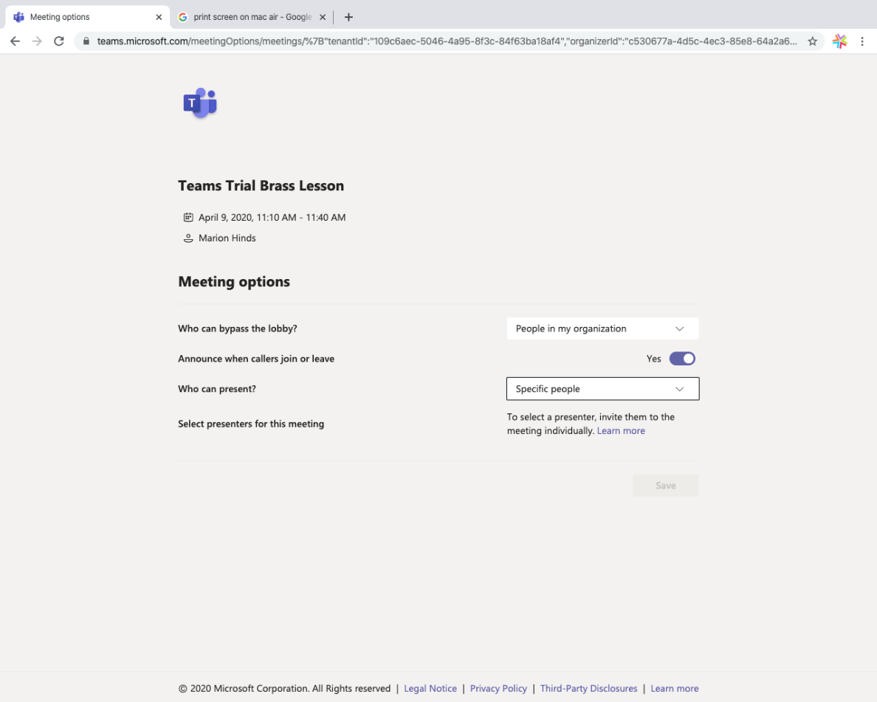
- This enables the Tutor to keep the pupil in the Waiting Room/Lobby until they are brought into the lesson.
- Our Safeguarding Team can ‘bypass the lobby and enter the lesson without being invited in. Parents / Pupils will see when someone enters the lesson as we will set ‘Announce when callers join or leave’ to Yes.
- Tutors will send a copy of the body of the invite that says Join Microsoft Teams Meeting to parents in an email. This hyperlink contains the meeting ID specific to each individual lesson and is required by each specific pupil to join their lesson.
3. Create a new Teams meeting for small group lessons.
Unfortunately Meeting invitations do not have a BCC option as an email does, this step will enable our tutors to send lesson times (Meeting requests) to ensure parent email addresses are not visible to others outside of the Music Service.
- Tutor creates a new email.
- Include details of the scheduled lesson (date, time)
- Include the parent (student) email address(es) in the BCC section.
- Paste the body of the meeting invite you copied in step 2 into the email – it is important to ensure it is the body of the meeting invite for the specific lesson as this includes the meeting ID that enables the student to join.
SCMS Tutors will also include the following in the meeting (lesson) invite (step 1) or email (step 3):
- When joining the lesson as a ‘guest’ advise pupils to join using the protocol of pupil's first name and initial of last name only.
- Advise that a person (Optional attendee) may appear mid lesson. This Optional attendee will be someone from the Music Service Leadership Team. This is part of our safeguarding and quality assurance process.
- During the online lesson the parent and pupil will know who is in the session as their initials appear in a circle. The initials you might see are: DS; MH; AC; BC; HS; TR; VT; BT; MS; NP.
- Remind parents and pupils that it is against our policy for us or pupils to record all or parts of lessons unless this is explicitly agreed with SCC/SCMS.

Students will be admitted to their lesson from the lobby (Waiting Room) where they will need to wait to be admitted to the lesson.
- The teacher will need to admit each student to the lesson. This can only be done if the teacher has joined the meeting via their SCC email address login.
- Pupils may wish to consider joining the lesson a couple of minutes before the scheduled start time so that they are ready and waiting to be admitted from the lobby feature.
- Teachers may wish to ‘blur their background’; this is a built in function to Teams that is achieved through one easy click. Blurring the background helps to minimise distractions to students, and helps with privacy. Unfortunately, students joining from outside SCC (i.e. non SCC email addresses) do not appear to be able to do this for their picture via the web link access or mobile device Teams App versions.

Join a meeting without a Teams account (for Pupils)
Pupils are able to join a meeting without having a Teams account BUT only on PC or LAPTOP – mobile requires app. Guidance on joining a meeting via Desktop and Mobile devices can be found at the official Microsoft support website.
https://support.microsoft.com/en-gb/office/join-a-meeting-without-a-teams-account-c6efc38f-4e03-4e79-b28f-e65a4c039508?ui=en-us&rs=en-gb&ad=gb#ID0EBBAAA=Desktop

Safeguarding / Lesson Observations
We can replicate current ‘safeguarding’ protocol of observing a lesson through a window or entering the classroom by joining the lesson via the Teams Meeting. In order to do this, Tutors need to have invited DS; MH; SM; or ST to the lesson in advance and via their SCC email address. This will enable them to bypass the lobby and just join the meeting.
- It is suggested that the nominated person just joins as audio as this will be less distracting than a video stream popping up. The nominated person will still be able to see the other video streams though.
- Tutors delivering lessons should advise the student(s) at the start of the lesson that someone may just ‘pop in’ to the lesson and who that would be.

Guidance for delivering and receiving interactive online tuition
Remember that safeguarding is just as important when teaching online as it is when teaching face to face.
SCMS will continue to apply our adopted code of conduct Guidance for Safer Working Practice
Identification - SCMS tutors will be required to display a means by which they can be identified (e.g. SCC ID badge), either on-screen or actual, at all times during the lesson.
SCMS tutors will protect themselves from accidental inappropriate contact with students by restricting any online profile (Face Book etc.) so that it does not automatically accept contact requests and is not accessible to students.
If using a profile picture ensure that it uses a business-like profile picture. Establish a serious and professional manner when using Video Conferencing technologies.
Students and their parents/carers are reminded that Teams is to be used for lessons only and not for other contact with tutors, e.g. general messaging. SCMS Tutors must only have online contact with pupils at the agreed scheduled lesson time.
Parents and pupils: It is against SCC policy for SCMS, parents or pupils to record all or any parts of lessons unless this is explicitly agreed in writing with SCC/SCMS.
Encourage students to restrict their own profiles so that they can only receive calls from known contacts.
SCMS Tutors must always confirm at the start of each lesson that an adult is in close proximity to the student. If an adult is not available at the student’s home, the lesson will not go ahead. A student is anyone under the age of 18.
Lessons must be delivered from a suitable location, for example not in bedrooms or bathrooms. It is useful for the pupil to be away from other noise, and to consider what is visible in the background particularly if there are more than 1 student in the lesson. Where drum kits are kept in pupil’s bedrooms agreement must be made with the Parent and SCMS Senior Tutor for tuition to take place. Cameras should only show the drum kit and pupil against a suitable background (e.g. blank wall).
Do not allow students, or other members of the household, to wear excessively informal attire or present against a messy background. If this happens, the SCMS tutor will terminate the call and communicate the reason afterwards to the pupil’s parent and their Line Manager. The same applies if a student behaves inappropriately, and it may be necessary to take further action if this happens, just as we would with a face-to-face lesson.
All lesson timings must match the SCMS Tutor’s Teams Calendar.
As part of our safeguarding and quality assurance process Parents and pupils are advised that a member of the Senior Leadership Team and Senior Tutor Team might pop-in to the lesson. They will aim to be as unobtrusive as possible and keep their audio and video feed muted.
- This Optional attendee will be invited to lessons and parents will see that in the lesson invite message they receive.
- During the online lesson you will know who is in the session as their initials appear in a circle. The initials you might see are: DS; MH; AC; BC; HS; TR; VT; BT; MS; NP.
- Not every lesson will have a ‘pop-in’. Where we are able, our intention is that only one other member of the SCMS team will ‘pop-in’ to the lesson.
Report any Safeguarding concerns as you would normally.

System Requirements
To deliver / receive lessons online:
- Microsoft TEAMS can be accessed in a number of ways: Parents and pupils can access Teams via: PCs or Laptops using the link in email meeting invite for web browser access; MOBILE PHONES & TABLET devices require download of an app. If downloading the App suggest this is done in advance of first lesson.
- Use of a network cable (wired internet connection) if available, rather than home WiFi may improve the connection. Wi-fi can be intermittent and give poorer quality connectivity.
- Make sure your computer / device is connected to power as online conferencing can drain battery power quickly.
- If using an external mic, headphones, or speakers check that everything is plugged in and working.
- You will need a Desktop computer, Laptop, Tablet, or Smartphone with built in front facing camera and built in speakers and microphone. If you don’t have these, you will need to purchase a web cam and/or headphones.
- A reasonable quality microphone can also improve the audio experience but is not necessary.

Links to Policy & Guidance

Safeguarding and Keeping Children Safe in Education
https://www.gov.uk/government/publications/keeping-children-safe-in-education--2

SCC Code of Conduct Policy
https://www.suffolk.gov.uk/assets/council-and-democracy/council-departments-services-and-senior-officers/SCC-Code-of-Conduct.pdf
Guidance for safer working practice for those working with children and young people in education settings May 2019 https://www.saferrecruitmentconsortium.org/GSWP%20Sept%202019.pdf

Interactive online teaching - FAQs

Q. How to present when using a video conferencing package?
A. | Dress smartly (casual is fine) and use a neutral background. Ensure that the teaching/learning space is suitable i.e. be careful of what else might be happening / or could happen without your knowledge / intent in your surroundings.
Q. I am experiencing ‘lag’ on the audio / video feed. Why is this?
A. | There could be many reasons. Availability of band-width and the broadband connection and connectivity in the geographical area / the home environments will both have an effect. Using a neutral background helps the camera to mitigate lag with audio and video streaming. Parents need to be aware that poor connection may be down to their broadband connection and therefore out of your control.  It may also be worth suggesting to parents (and teachers) that use of a network cable (if they have one) rather than home WiFi may improve their connection.
Q. | Why can’t I see the pupil very well / they can’t see me very well.
A. | It may be necessary to widen the frame depending on your instrument, so take care that the frame is well chosen and appropriate.
Q. | I’m not really prepared for this, what do I do?
A. | In the initial instance working via video conferencing may require the teacher to alter their teaching approach, and the pupil will similarly need to change their approach to interactions and responding to requests from the teacher. This will be a learning curve for us all and the best advice is to go slowly, try a few lessons, talk so that we iron out any problems where possible and just enjoy having the lesson and interaction.
Q. | Is Teams a safe platform for us to be using?
A. | Yes. SCMS tutors are using this with the @suffolk.gov.uk addresses (domain) and using our O365 (SCC) accounts. These are all accessed through SCC IT contracts. Our Safeguarding protocols have been agreed by SCC.
Q. | Can I use my own personal Computer? (SCMS Tutors)
A. | Yes. You can use O365, the Teams App (log-in using your @SCC details), or Teams via a web browser. You must make sure that and log onto the SCC SharePoint platform. If you must download anything to your own machine immediately upload to the SCC One Drive and delete from your personal machine. Refer to the Working away from the office and use of IT guidance.
Q. | Will the Teams lessons be recorded and archived.
A. | No. Whilst it is possible to do this the SCC policy is not to at this time.  Parents and pupils: It is against SCC policy for SCMS, parents or pupils to record all or parts of lessons unless this is explicitly agreed in writing with SCC/SCMS.

