Answers 29th April

Reading – Scarecrows

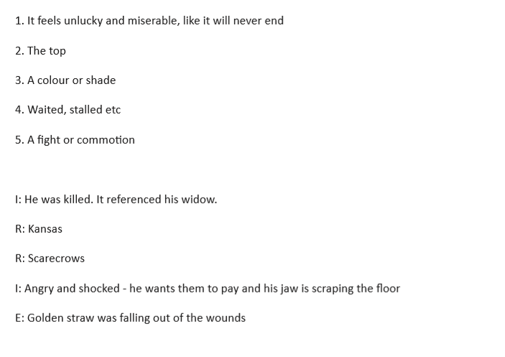

Year 5 Maths Millimetres and Millilitres
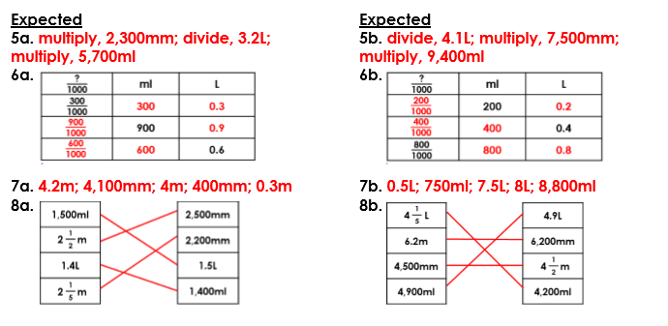
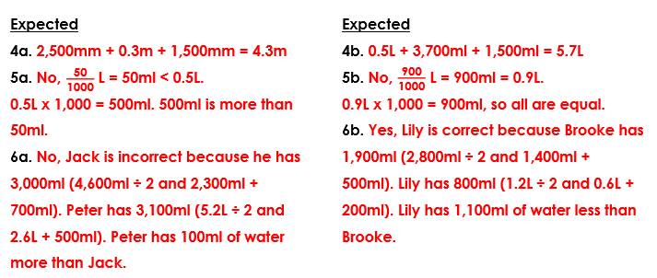

Year 6 Maths – Counting Cubes

