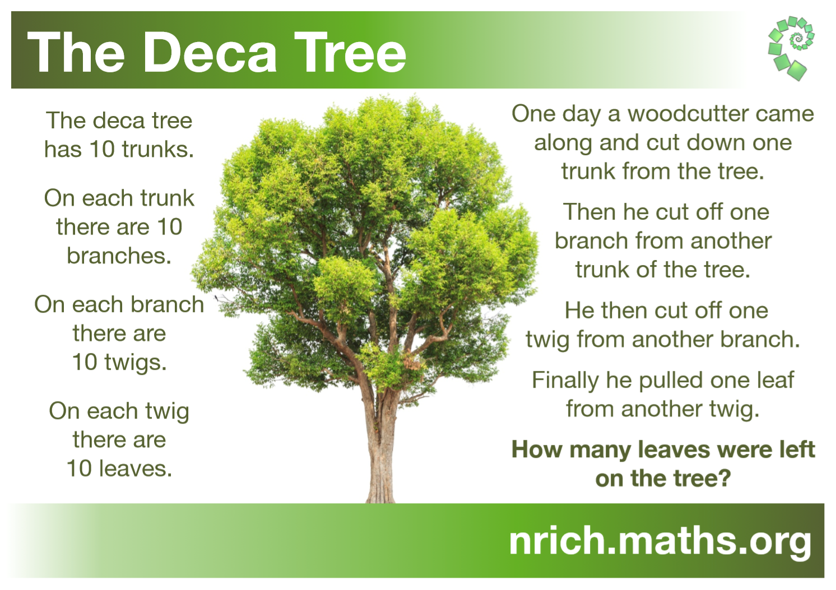

Solution:

There are 10 leaves per twig

There are 10 twigs per branch

10 leaves x 10 twigs = 100 leaves per branch

There are 10 branches per trunk

100 leaves x 10 branches = 1000 leaves per trunk

There are 10 trunks per tree

1000 leaves x 10 trunks = 10 000 leaves on the tree

Cut off one trunk: 10 000 - 1000 = 9000 leaves left

Cut off one branch: 9000 - 100 = 8900 leaves left

Cut off one twig: 8900 - 10 = 8890 leaves left

Pull off one leaf: 8890 - 1 = 8889 leaves left

There are 8889 leaves left on the tree.