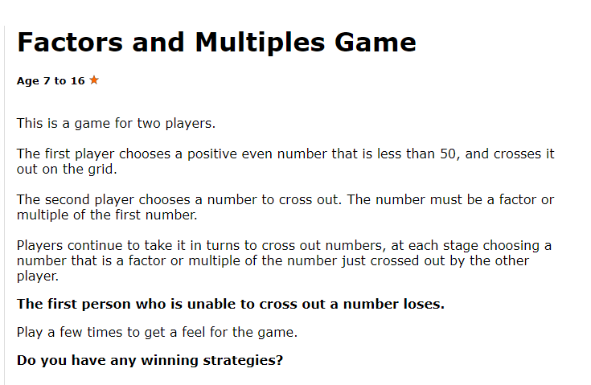

Remember a factor is a number that divides into another number equally. E.g. 3 is a factor of 9.
A multiple is a number that divides equally by another number e.g. 15 is a multiple of 1, 3, 5 and 15.

