Hinduism Concepts and Key Questions covered
Key Stage 2
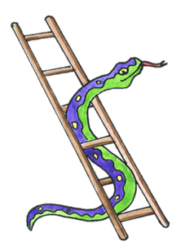  Why do Hindus want to collect good karma? | 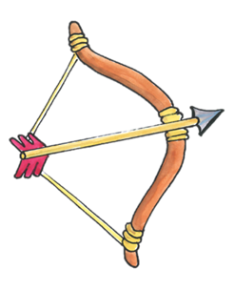  How does the story of Rama and Sita inspire Hindus to follow their dharma? | 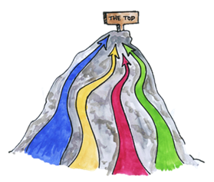What spiritual pathways to Moksha are written about in Hindu scriptures? | 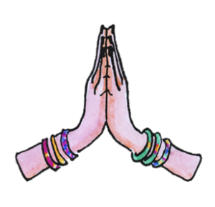How do questions about Brahman and atman influence the way a Hindu lives?

End of phase Hinduism Core knowledge : What do we want pupils to know?
By the end of KS2, pupils learn that Hinduism is a complex tradition which draws on many ancient philosophies. They will encounter some of the traditional stories told to Hindu children and some of the inspirational figures. Pupils will learn some of the key teachings about the Hindu’s Supreme Being Brahman and other deities worshipped. They will learn that Hindus take their religious responsibilities seriously; and that even Hindu children must learn to take responsibility for gathering good karma in an attempt to break the cycle of birth and re-birth.

