Ancient Mayas
Look at these pictures what can you tell about ancient Maya life?

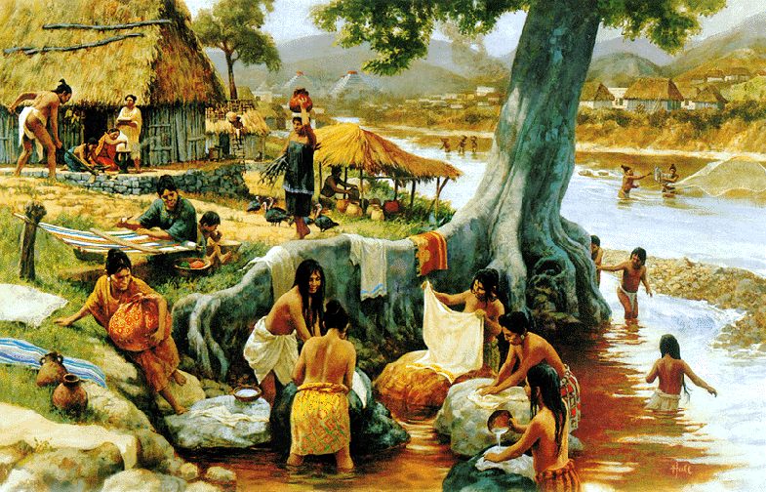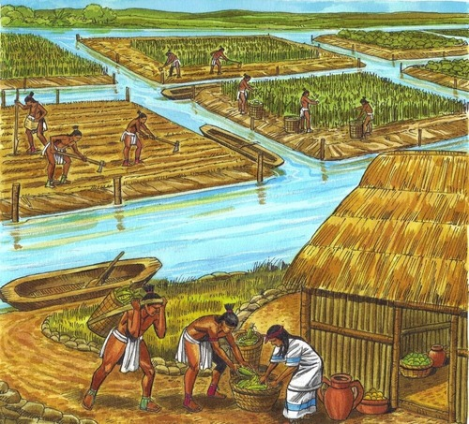
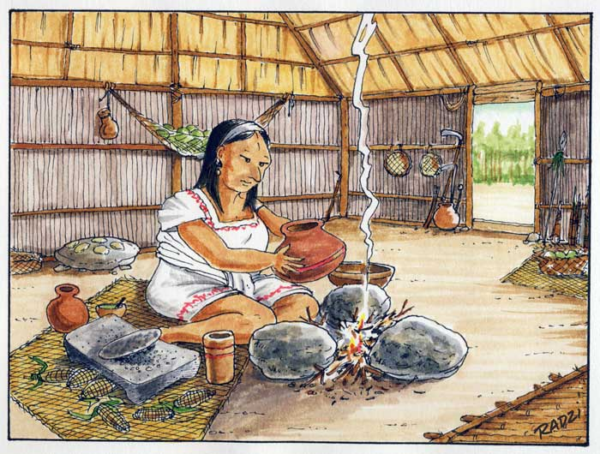
Does it remind you of any other time periods we have studied in history? What is the same?
Brainstorm as many ideas as you can. Can you find where the ancient Mayas are from and find it on a map?

