Lord’s Prayer Day
All of the children were involved in a creative day on 12th February 2016 to explore phrases from the Lord’s Prayer and what they really mean. Each year group took responsibility for creating a display for each phrase which is now in the hall.
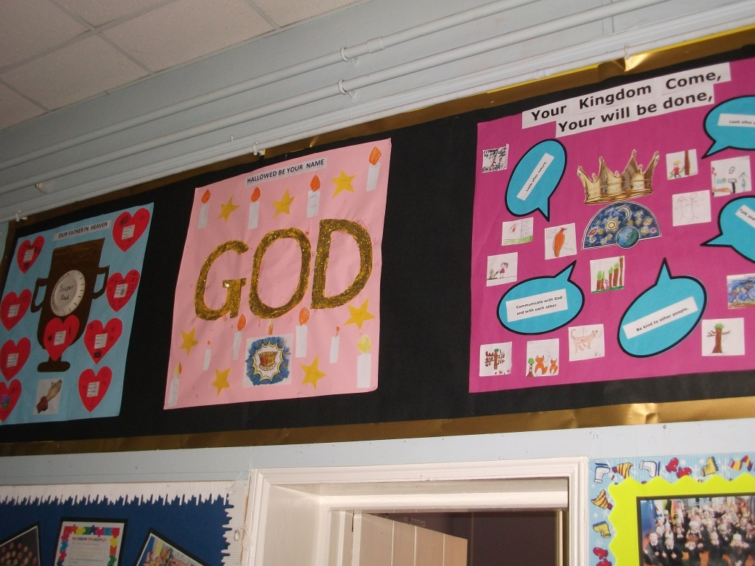
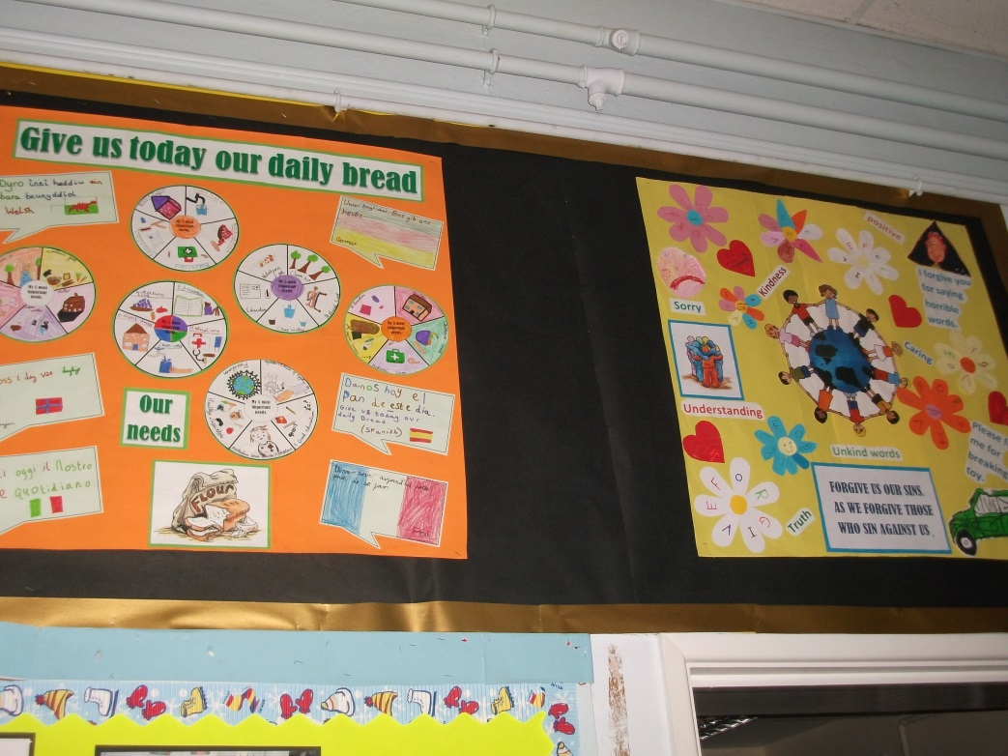
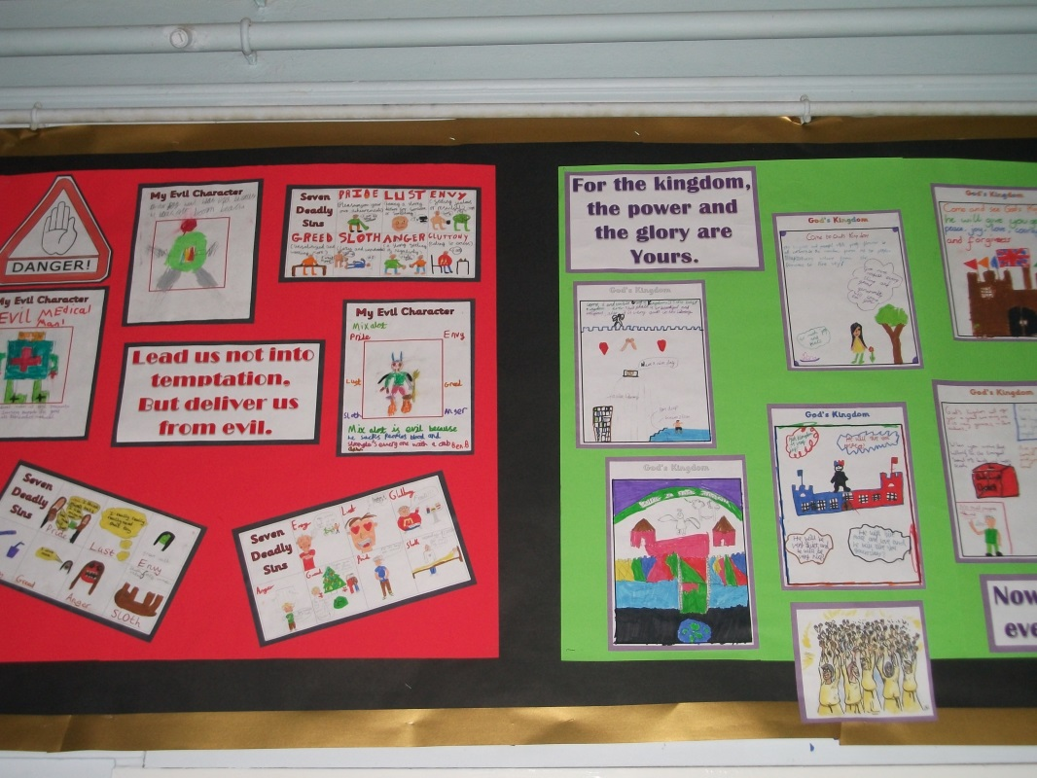
Sandra and Carolyn from our Open the Book Team came in to do some reflective story telling about Jesus teaching his disciples how to pray with the Lord’s Prayer.
