Welcome to Suffolk County Music Service Remote Learning for WCET Classes.

**WCET Lesson 3 w/c 25 January 2021**

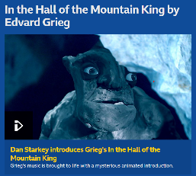Here are some musical activities for you to do at home or in school, and a new piece for you to learn to play on your instrument if you have it. If you don’t have your instrument, don’t worry! Listen to the piece instead and learn what it sounds like so that when you come back into school you can play with your class. Have fun!

Activity 1: Learn about some music that tells a story

[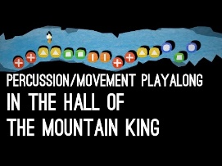](https://www.youtube.com/embed/e6XxTGXly-M?feature=oembed) (ctrl + click on the link or click the picture)

[BBC 10 Pieces The Hall of the Mountain King](https://www.bbc.co.uk/programmes/articles/1rpRf1Q7cK683F9LlwqTb5x/in-the-hall-of-the-mountain-king-by-edvard-grieg) Activity 2: Rhythm work.

Follow this link to see what it is: [Mountain King Playalong](https://www.youtube.com/watch?v=e6XxTGXly-M)

[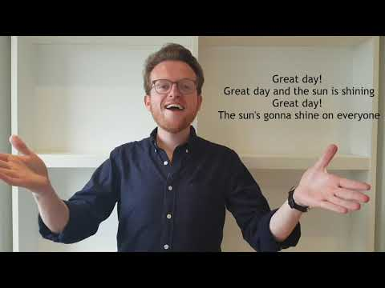](https://www.youtube.com/embed/Q8vtoJ2Z6_c?list=PL2tFLT5qytwSvecjNQv0fgDcYUkkcL0mN)Activity 3: Sing with professional singers Voces8 – there’s a warm-up and three songs to choose from.

[A Cappella Lego 4 (Interactive Video) – YouTube](https://www.youtube.com/watch?v=Q8vtoJ2Z6_c&list=PL2tFLT5qytwSvecjNQv0fgDcYUkkcL0mN&index=4) The warm-ups change to songs at 8mins 51 on the video.

Activity 4: Here’s your piece for this week

