Needs and Wants
What is a ‘need’? What is a ‘want’?
A ‘need’ is something that is essential and a ‘want’ is something that is desirable and you could live without.
Think about whether these are needs or wants and circle the word you think it is. There are no right or wrong answers. Make notes of the key points of your ideas.

- Is a home a want or a need? Want Need
- Is a car a want or need? Want Need
- What about a phone? Want or need? Want Need
- School shoes? Want or need? Want Need
- How about television? Want or need? Want Need
- Is a take-away pizza a want or need? Want Need
- Is soap a want or need? Want Need
- Is a Premier League football strip a want or need? Want Need
- Are designer trainers a want or a need? Want Need
- What about bottled water? Want or need? Want Need
- What about heating? Want or need? Want Need
- Finally, what about school, a want or a need? Want Need
Have a look at your answers. Do you think that everybody would agree with your choices? If not, why not? What might have an impact on your decision?

Now think about the list again, but this time as if you were an adult. How do things change? Do you need to take different things into consideration?

How might things change if you were very wealthy or very poor, living after a disaster or in a war zone, in the past etc?

Needs and wants can change and can be different for different people and for different reasons.

What do you think are the real essentials? Compile a list. There may be some items, like a TV or computer, which you may feel are essential. Make a separate list called ‘We could live without them but.......’
What do you think we can do about our ‘wants’? Why can’t we always have what we want straight away?

You should be familiar with the phrase ‘not being able to afford something’. What can we do then?

Consider what you could do:
- Budgeting
- Planning to spend
- Saving up
- Borrowing (i.e. a loan)
- Getting credit (i.e. on a credit card or on a finance scheme – buy now, pay later)

What does it mean if you ‘invest’ your money? What are the risks?

Short-term and Long-term Goals:

Setting goals for yourself can help you save money for things you want or need. The easiest thing to do is think about what you want to spend your money on now and what you might want to save it for later.

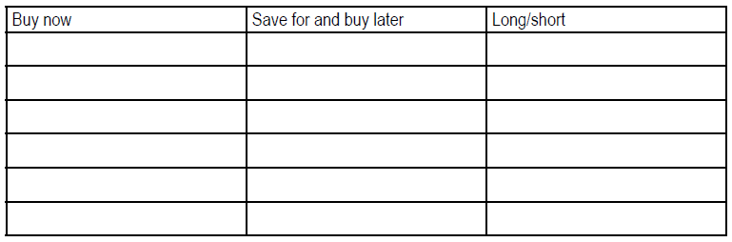

A short-term saving goal means you plan to have enough money for the thing you want in a few weeks or months. A long term saving goal means it will take you much longer to save up, several months or even years, because the item is more expensive. You might just save ‘for a rainy day’ and not for anything in particular.

Which of your things are long and which short term savings goals?

How can you reach your saving goals?

You need a Savings Plan. Each time you get money you decide to save a regular amount of it, no matter what. You could set aside 25%, 50%, as much as you want which allows you to still spend the money you want to spend.

Work out this example: Imagine you usually get £5.00 per week pocket money and earn another £3.00 doing a job. You will also get some money for presents etc. You save 25% of all money you receive.

How long will it take you to save up for a T-shirt (£15) or a bike (£75)? Fill in the plan below:

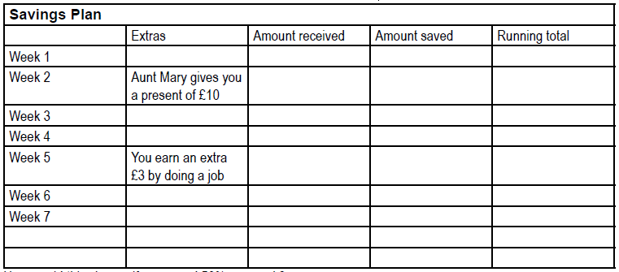

How would this change if you saved 50% per week?
Work out a plan of your own to save for something you want.

