A Monster Calls ~ Writing activities
Your story must be handwritten making sure you remember your capital letters, apostrophes, end of sentence punctuation and are checking your spellings. I expect a high standard of presentation – please use a black handwriting pen.
Monday + Tuesday – Bringing it all together: You will need to look back at all of the sentences that you have written over the last few weeks as these will all form part of your story.
My complete story is on the next page so that you can see how it all fits together.
TASK: For most of the writing activities, you had to write at least two different versions of the same story. You will need to make a decision about which sentences to include in your final draft.
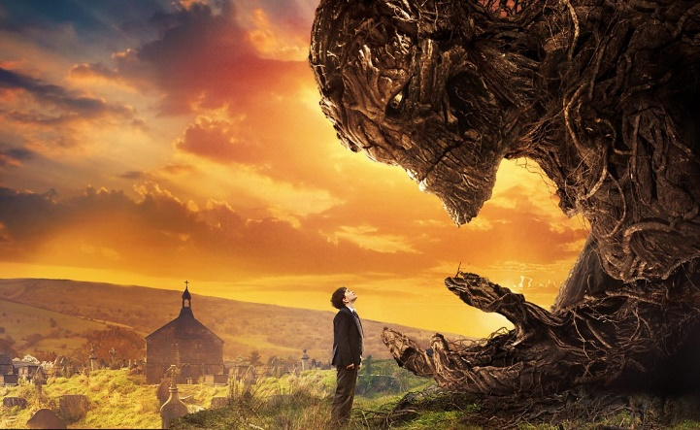
The plot points are:
- Conor wakes from a nightmare
- Safe, familiar objects as time stands still
- Powerful moonlight imagery
- Conor’s emotions and angry red eyes emerge
- Invitation from the monster
- The monster’s rampage
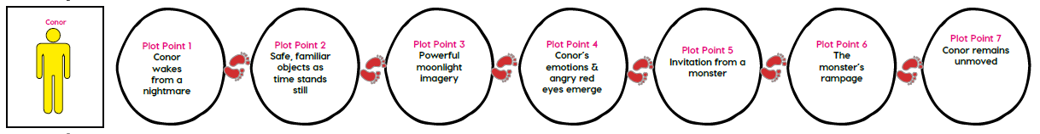
- Conor remains unmoved

Over the next two sessions, you will need to write out the whole of your story using the plot points and the Sentence Stacking Techniques that you have been practising:
- List-like phrases
- Short sentences
- Fronted adverbials & rhetorical questions
- Time clues
- Complex sentences
- Relative clauses
- Personification & Alliteration
- Adjectives in unusual positions
- Onomatopoeia
- Using dialogue & Similes
- Alliteration & Synonyms
- Subjunctive form
- The Power of Three
- Using action & Personification
- Synonyms & Repetition
- Subordinating Conjunctions

You need to write on lined paper. Make sure you are writing using paragraphs and are organising any dialogue correctly.
A Monster Calls – Teacher Model
Conor had a nightmare: the horrifying, howling wind; a torturous trickle of blood; sudden, short breaths; and a sinister, shadowy figure. He woke. He woke gasping. He woke trembling. Only semi-conscious, Conor sat up in bed. ‘What was that?’ he thought. Something was unfamiliar… something was different… something was very unfamiliar and very different.
12:07. Seven minutes past midnight. For Conor, time dragged desperately as his heart pounded in his chest. It was beating twice as fast as the ticking clock. Emerging from the darkness was his familiar teddy bear, his comforting duvet and the reassuring clicking of his radiator. Conor, who had leaned closer to the edge of his bed, looked back at the frozen clock.
The light of the moon cut through the darkness. The magnetic moon beckoned Conor. Shadows lingered in the garden – sinister, threatening.
Crash! The earth ripped. Thud! The soil parted. Boom! The terrain tore.
“Am I still in my nightmare?” thought Conor to himself calmly. Piercing from the depths were eyes as red as fresh embers. Conor watched as the tree emerged from the ground. Twigs tangled, roots wrenched and leaves laced to form the monster of his nightmares. Conor stared out at the beast. The monster lowered its gnarled twig-like hand.
“COME WITH ME!” it bellowed.
Conor said, “If I were to put myself in your hands, if I were to go with you, if I were to trust you, then what would you offer me?”
“I have come to get you Conor O’Malley,” thundered the monster.
“I’ll do what I want,” said Conor casually.
Stomping across the soil, the monster strangled clouds, tore at trees and pummelled brickwork. The clouds hid behind the moon, the trees trembled and the bricks shuddered in fear.
A real monster. An enormous real monster. An enormous, angry real monster. Shrugging his shoulders, yawning nonchalantly and leaning on the windowsill, Conor watched the monster. Despite the monster’s aggressive, threatening presence, Conor felt no fear.
“Shout all you want,” Conor shrugged, barely raising his voice. “I’ve seen worse.”

Wednesday – Planning your own version: I would like you to plan your own version of the story, using the 7 plot points below in the grid. Choose your own character and monster. Think about how the monster is going to be formed and from what – perhaps something other than a tree that is outside your character’s house. Write notes.

Main character

Main character: |  |  | Monster:
Plot Point | What happened in the original story | My version of the story
1 | Conor wakes from a nightmare
2 | Safe, familiar objects as time stands still
3 | Powerful moonlight imagery
4 | Conor’s emotions & angry red eyes emerge
5 | Invitation from a monster
6 | The monster’s rampage
7 | Conor remains unmoved

Thursday/Friday – Writing your own version: This task is over the next three sessions. Use your plan to write your own version of the story, using the same structure but a different main character, monster and perhaps setting.
You will need to write out the whole of your new story using the Sentence Stacking Techniques that you have been practising:
- Onomatopoeia
- Using dialogue & Similes
- Alliteration & Synonyms
- Subjunctive form
- The Power of Three
- Using action & Personification
- Synonyms & Repetition
- Subordinating Conjunctions
- List-like phrases
- Short sentences
- Fronted adverbials & rhetorical questions
- Time clues
- Complex sentences
- Relative clauses
- Personification & Alliteration
- Adjectives in unusual positions

Your story must be handwritten on lined paper, making sure you remember your capital letters, apostrophes, end of sentence punctuation and are checking your spellings. You need to write using paragraphs and organise any dialogue correctly.
I expect a high standard of presentation – please use a black handwriting pen.
THURSDAY, YOU WILL NEED TO UPLOAD A PHOTO OF YOUR STORY SO FAR SO I CAN GIVE YOU ANY FEEDBACK. MAKE SURE THAT YOU RE-READ AND EDIT YOUR WRITING BEFORE YOU UPLOAD A PHOTO ONTO THE DAILY DISCUSSION.
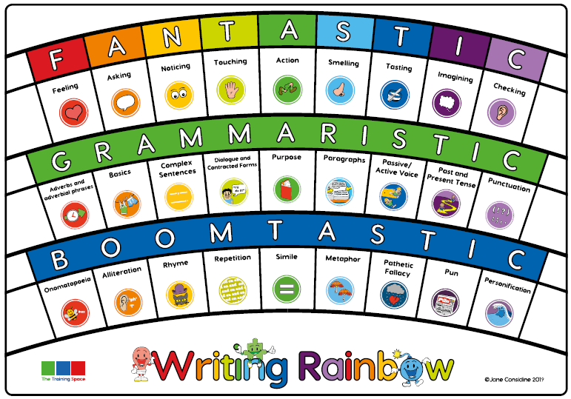
YOU WILL NEED TO UPLOAD A PHOTO OF YOUR FINISHED STORY TO THE HOMEWORK TAB ON FRIDAYSO I CAN MARK IT.

