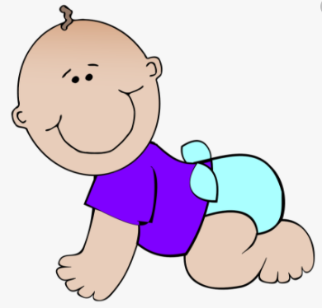

Absorbency Challenge

Your challenge is to test which materials are the most absorbent.
You will need to find household materials such as toilet roll, kitchen towel, writing paper, dish cloths, dusters.
Think carefully what you need to do to make your test fair - You only change the material you are testing, everything else must remain the same. (Remember the friction tests with the wheels)
How will you decide which material has absorbed the most water?
You could put the water in a jug with the water and the material, take the material out and measure the water left. Or you could soak up water using the material then squeeze it in a cup and measure how much is in the cup.
You need to record your results so you can decide which was the most absorbent.
Use the grids on the blog to record your experiment as you go.

